Cross Region Disaster Recovery

In this project I built an identical architecture across two different regions, us-east-1 and us-west-1. Then placed an auto scaling, load balanced architecture within the default VPC and connect it to an Amazon RDS MySQL database in the primary Region (us-east-1).

The RDS MySQL database will have a Read Replica in the Secondary Region (us-west-1) and I stored the database credentials as a secret in AWS Secrets Manager. Failover routing with Amazon Route 53 will be used to automatically fail over from the primary Region to the secondary Region when I simulate the failure of the primary Region.

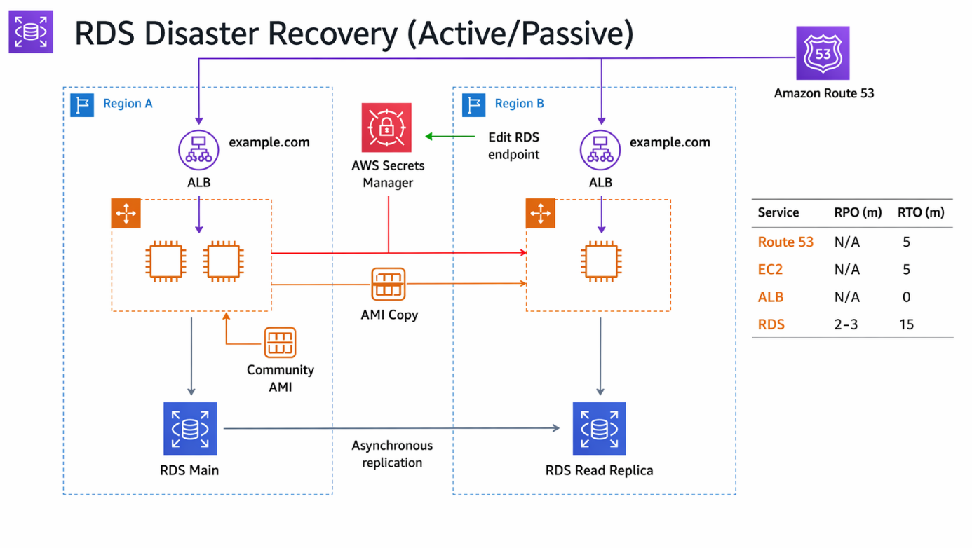

Requirements (Prerequisites)
- AWS Free Tier Account
- Hosted zone / Domain name in Route 53
Resources
See folder called “cross-region-disaster-recovery” in the GitHub repo

Exercise Overview
Exercise 1 – Create Security Groups in us-east-1
Exercise 2 – Build the RDS MySQL database in us-east-1
Exercise 3 – Launch the first instance and create the Database Table
Exercise 4 – Create the Read Replica in us-west-1
Exercise 5 – Store the Database credentials in AWS Secrets Manager Exercise 6 – Create an Amazon Machine Image from the Instance in the primary Region
Exercise 7 – Create the Launch Configuration, Auto Scaling Group, and the
Application Load Balancer in us-east-1
Exercise 8 – Create the Route 53 Failover Policy
Exercise 9 – Replicate the compute environment in us-west-1
Exercise 10 – Update the Route 53 Failover Policy
Exercise 11 – Simulate failure and test failover

Exercise 1 – Create Security Groups in us-east-1
Task 1 – Create Security Groups in us-east-1

First, create the Security Groups for the EC2 instances which will form the compute layer with the primary Region (us-east-1).
- Go over to the EC2 management console and click on Security Groups on the left-hand side of the page.
- Click ‘Create Security Group’.
- Call the Security Group: ‘dc-php-webapp-webservers-sg’.
- Create in the default VPC.
- Add two rules, HTTP from anywhere (IPv4) and SSH from anywhere (IPv4) – it should look like this:
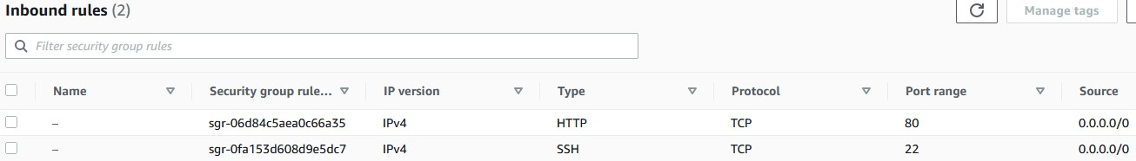

- Click create.
- Create another security group called ‘dc-php-webapp-dbservers-sg’ also in the default VPC.
- For the inbound rule, add ‘MySQL/Aurora’ port 3306 with the source being the Web server security group we previously created. Like this:

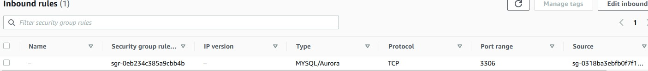

- Click create.

Exercise 2 – Build the RDS MySQL database in us-east-1
Task 1 – Build the database in us-east-1

Now create the MySQL RDS database in the primary Region (useast-1).
- Go over to the RDS Console and click ‘create database.’
- Within the console select ‘standard create’.
- Select MySQL and select ‘dev/test’ under the sample template options. Choose ‘single instance’ under Availability and Security.
- For ‘DB instance identifier’ use the name ‘dc-php-webapp-database’ and choose admin for the master username, and ‘password’ for the password. Make a note of these as they will be used later.
- Change the storage type to ‘General Purpose SSD (gp2)’ and set the allocation to 20 GB.
- Scroll down and select the Default VPC and choose the ‘dc-php-webapp-dbserverssg’, deselecting the default security group.
- Expand the additional configuration and call the initial database ‘sample’.
- Click create.
- Once created make a note of the RDS endpoint.

Exercise 3 – Launch the first instance and create the Database
Table
Task 1 – Create an IAM Role

We will now create the IAM Role which will be used to access the secret from AWS Secrets Manager.
- Go over to the IAM console and click ‘Policies’.
- Create new policy and click on the JSON tab and paste in the JSON code from the resources download called ‘dc-php-webapp-webserver-secrets-access.json’ and call it by the same name (without the .json).
- Then click create.
- Now create a role from the policy by clicking ‘Roles’, ‘Create role’, select EC2 as the use case, and select the policy just created. Call it ‘dc-php-webapp-webserversecrets-access-role’.
- Click Create.

Task 2 – Launch the first instance from the shared AMI (public) and use to create DB tables (us-east-1)

Launch the first EC2 instance in the primary Region (us-east-1) and use it to connect to the Database and create the first table. You will make a custom AMI from this instance later.
- Head to the EC2 console and click ‘Launch instance’.
- We will call this ‘dc-php-webapp-ami’.
- For the AMI, click ‘browse more AMIs’ and head over to ‘Community AMIs’.
- The AMI id is the following: ‘ami-0501e1ca29a191252’ if you search for this one AMI should show:

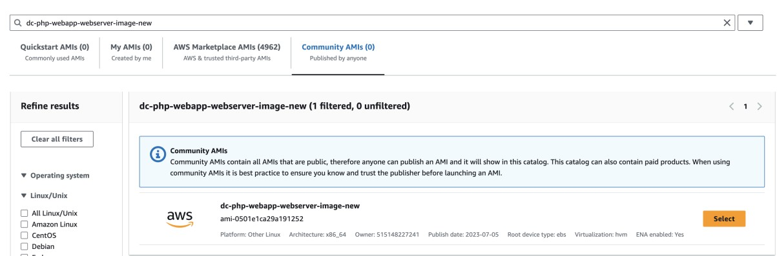

- Select this AMI and choose ‘proceed without a key pair’.
- Select the ‘dc-php-webapp-webservers-sg’ security group and remove the default security group.
- Select the IAM role created earlier and click launch instance.
- Once launched and running, connect to the instance using EC2 instance connect.
- Run the following two commands to update the instance and install mysql:
sudo yum update -y
sudo amazon-linux-extras install php8.0 mariadb10.5
- We are now ready to connect to the database. Run the following command, adding the database endpoint in the middle.

Note: the database commands are also included in the ‘db-commands-frominstance.md’ file in the resource download.

mysql -h **YOURENDPOINTHERE** -u admin -p
It should look like this:

Enter your password and connect:
- You now need to create the tables within the database called sample;
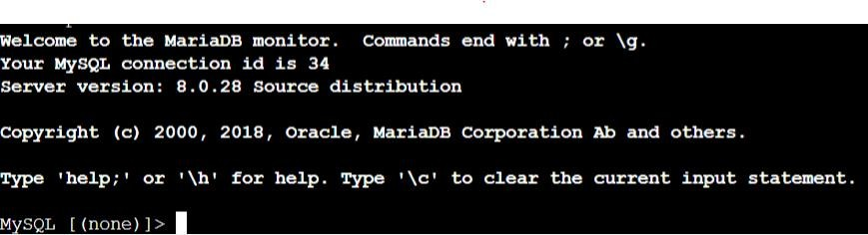

use sample;

- Then run the following SQL statement to create the table:

CREATE TABLE orders (id INT(6) UNSIGNED AUTO_INCREMENT PRIMARY KEY, ordernumber VARCHAR(30) NOT NULL, customername VARCHAR(30) NOT NULL, address VARCHAR(150) NOT NULL, item VARCHAR(50) NOT NULL, price DECIMAL(10,2)
NOT NULL, date TIMESTAMP DEFAULT CURRENT_TIMESTAMP ON UPDATE
CURRENT_TIMESTAMP);

- You are now ready to launch the read replica in the secondary Region (us-west-1).
Exercise 4 – Create the Read Replica in us-west-1
Task 1 – Create a read replica of the main database in the secondary Region (us-west-1)

You will now create the read replica of the main database in the secondary Region which you promote and failover to later.
- Create the same security groups in us-west-1 as us-east-1 and modify the database to use the correct DB security group.
- Click on the database, click on ‘Actions’ and ‘Create Read Replica’.
- Select the secondary Region (us-west-1, N.California) and set the ‘DB instance identifier’ to ‘dc-php-webapp-database-west’.
- Remove the default security group and add the DB security group.
- Click ‘Create Read Replica’. We should now see it provisioning if we go to the RDS console in the us-west-1 Region.

Exercise 5 – Store the Database credentials in AWS Secrets
Manager
Task 1 – Create a Secret within Secrets Manager
You will now create a Secret within AWS Secrets Manager to store the database parameters. This will allow us to easily failover from the Primary Region to the Secondary Region later.
- Go the AWS Secrets Manager console in us-east-1 and click ‘store a new secret’.
- Under ‘Credentials for Amazon RDS database’ add your username and password which we configured earlier, and choose the database instance which we created earlier:

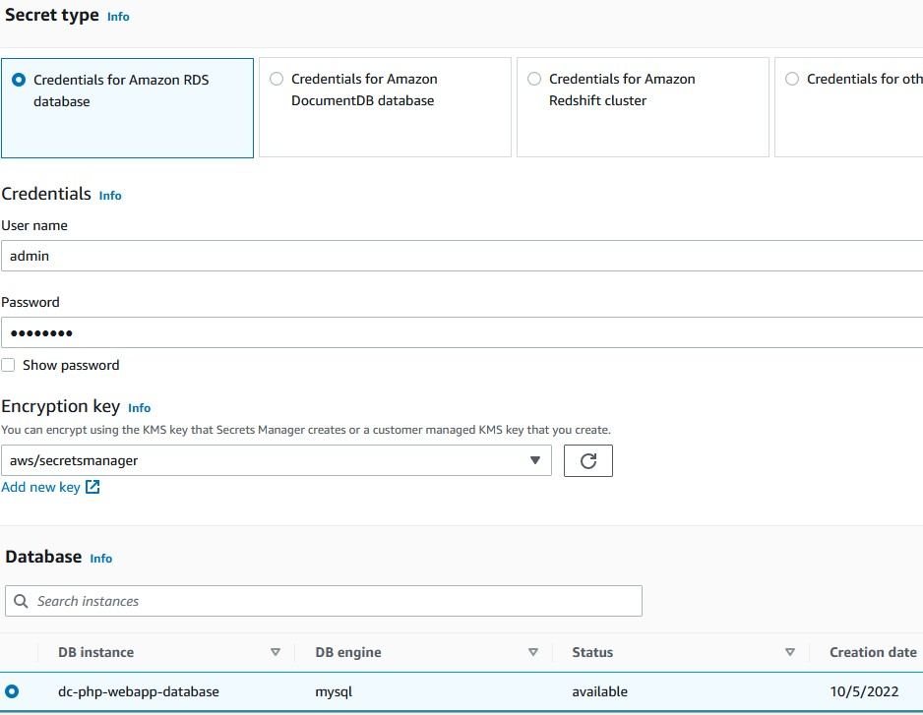

- Set the name to ‘dc-php-webapp-db-secret’ – this is very important as the code bundled in the AMI references this secret.
- Create the secret.

Exercise 6 – Create an Amazon Machine Image from the Instance in the primary Region
Task 1 – Build a custom AMI from the currently launched instance
We will now build a custom AMI from the currently launched instance that will be used in the launch template for the auto scaling group.
- Open the Amazon EC2 console.
- In the navigation pane, choose ‘Instances’, select your instance, and then choose ‘Actions’, ‘Image and templates’, ‘Create image’.
- On the Create image page, specify the following information, and then choose ‘Create image’.
- Image name: dc-php-webapp-image
- Tick the box under ‘no reboot’ and click create AMI.
Task 2 – Copy the AMI from us-east-1 to us-west-1

With this task we will copy the AMI from the primary region (us-east-1) to the secondary Region (us-west-1). We will then use this later to build the secondary environment.
- Go to AMIs when in the us-east-1 Region and select the AMI.
- On the actions menu select ‘Copy AMI’ and for destination Region select ‘US West (N.California)’.
Exercise 7 – Create the Launch Template, Auto Scaling Group, and the Application Load Balancer in us-east-1
Task 1 – Create the Launch Configuration.

In this task we will create a launch template, auto scaling group and application load balancer.
- In the EC2 management console, click ‘Launch Templates’ and then click ‘Create launch template’
- For the launch template name, enter ‘LabTemplate’
- Under ‘Application and OS Images’ click ‘My AMIs’ and select the AMI created earlier.
- Select t2.micro as the instance type, proceed without key pair and choose the ‘dcphp-webapp-webservers-sg’ security group.
- Attach the ‘dc-php-webapp-webserver-secrets-access-role’ IAM role.
- Click ‘Create launch template’.

Task 2 – Create the Auto Scaling group.

Next you now create the Auto Scaling Group using the Launch Configuration as a template.
- Go to Auto Scaling Groups and select ‘Create Auto Scaling group’.
- Enter the name ‘ASG1’, select the launch template, and choose the default public subnets within the default VPC (us-east-1a and us-east-1b).
- Click next, select ‘No load balancer’ and click next again – we will now add the value 2 into each option:

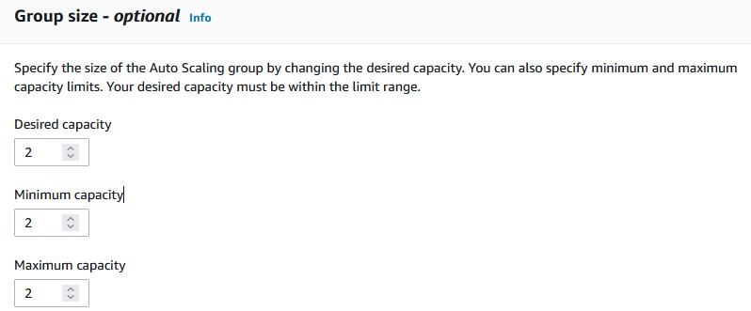

- Skip to review and create the Auto Scaling group. You should now see two instances launching in the EC2 console.

Task 3 – Attach an Application Load Balancer

Next, we can create and attach the Application Load Balancer for us-east-1.
- Create an Application Load Balancer named ‘ALB1’, ensure it is internet facing, select the us-east-1a and us-east-1b public subnets, and use the webserver security group we created earlier.
- Create a target group that uses HTTP and port 80 and register the instances that were launched by the ASG.
- Click update – and you should see the load balancer being built.
- We should now have a functioning application sitting behind the load balancer.
- You can now test that your application works. Copy the DNS name of the load balancer to a web browser. You should see this page:

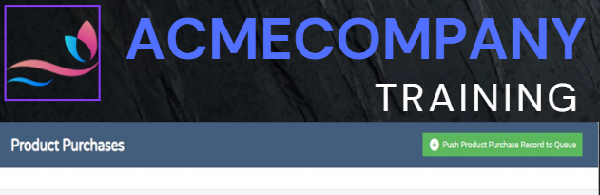

- Click “Create” and add some order information.
- Then click “View results” and it should display the order information you submitted. This is being retrieved directly from the RDS MySQL DB.

Exercise 8 – Create the Route 53 Failover Policy
Task 1 – Create the failover routing policy.

We now create failover policy which will mark the primary region’s load balancer as the primary target – we add the failover region in the next step.
- Go to the Route 53 console and click on ‘Hosted zones’.
- Find the public hosted zone you want to use and click ‘Create Record’.
- We will need to create an Alias record pointing to the Application Load Balancer hosted in us-east-1. This will be using failover routing and this Application Load Balancer will be marked as the primary.
- We will also need to create a health check – follow the link titled ‘info’ next to health check ID and click the console link.
- You will now be in the health check console in a new tab:

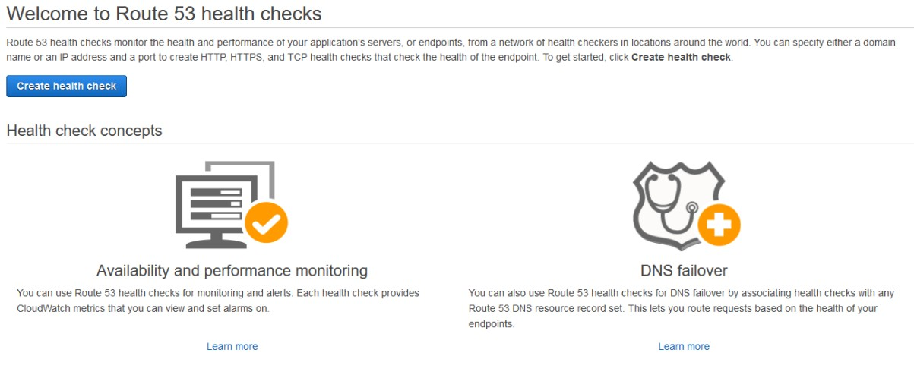

- Click ‘Create Health Check’.
- Call the health check ‘Eastern health check’ and add the DNS name of our load balancer located in us-east-1 in under the ‘monitor and endpoint’ tab.
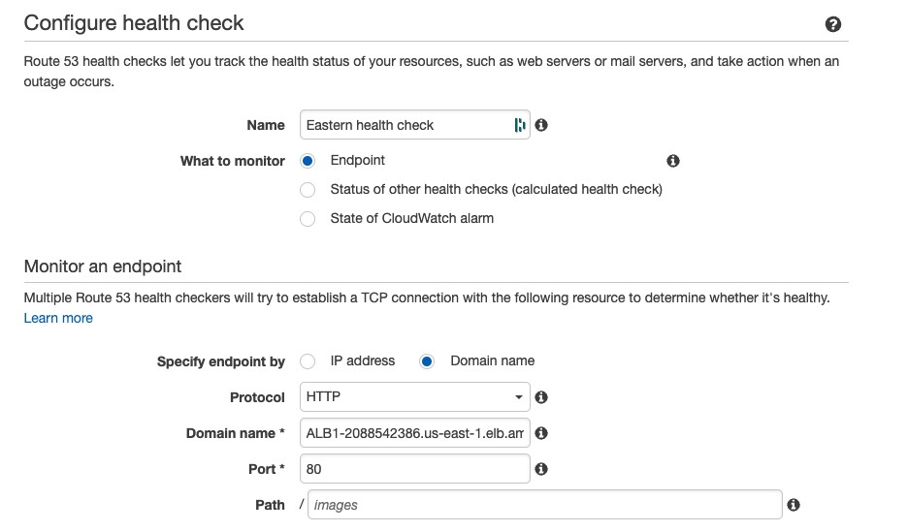

- On the next page skip the creation of a SNS topic and create the health check.
- You should now be able to add the health check in the failover record.
- Under Record ID call it ‘Primary’ and click ‘Create Record’.
- You should now be able to connect to the application using your public DNS domain name.

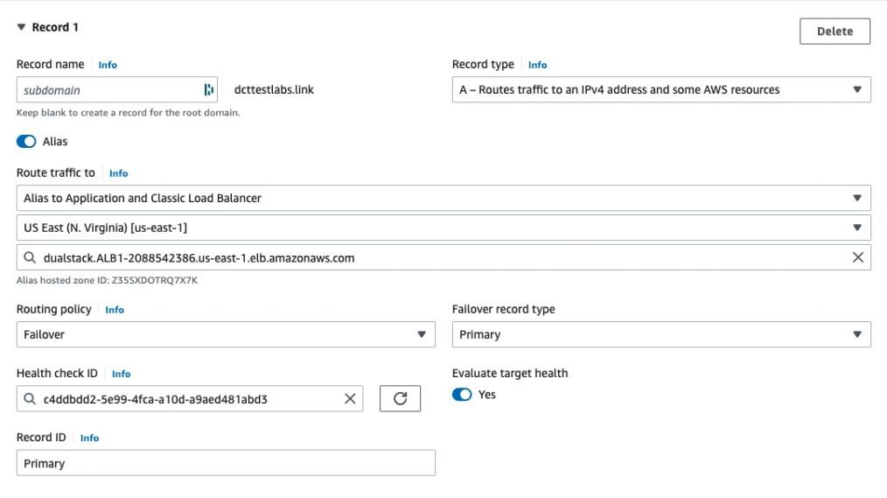

Exercise 9 – Replicate the compute environment in us-west-1
Task 1 – Create the Launch Template, Auto Scaling Group and
Application Load Balancer

We will now follow the identical instructions for launching the compute layer in the secondary Region (us-west-1).
- Ensuring you are in the us-west-1 Region, go through the instructions from earlier in the document, until you have the identical infrastructure in both the primary and failover Region.
- This will include the Security Groups (if not already created), Launch Template, ASG, and ALB. You will use the copied AMI for the launch template.
Exercise 10 – Update the Route 53 Failover Policy
Task 1 – Add the secondary region to the failover policy.

We will now finish the creation of the Route 53 failover policy.
- We will also need to create another health check named ‘Western Health Check’ pointing to the load balancer in the secondary region by following the same steps as earlier.
- Next, go to Route 53 and under the hosted zone which we used earlier, click create record. Create an alias to the ALB.
- Select the load balancer from us-west-1, configure Failover routing, and set the Failover record type to ‘Secondary’. Include the health check ID just created.

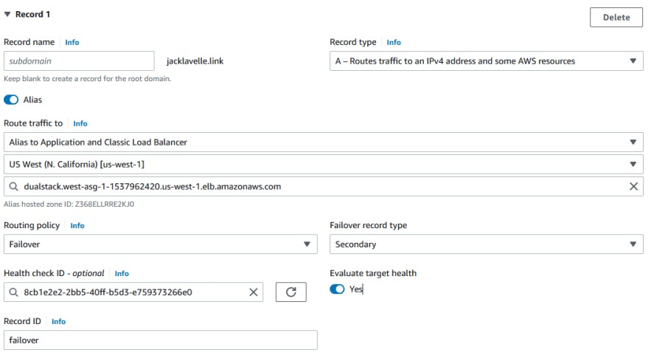
- Click ‘Create records’.

Exercise 11 – Simulate failure and test failover
Task 1 – Delete the primary database and promote the read replica.

We will delete the primary database and then promote the read replica in the secondary region.
- Go to the primary Region (us-east-1) and head to the RDS console.
- Highlight the Database and click ‘Delete’.
- We do not need to keep any backups and tick the box confirming deletion.
- After a short period of time, you should see the connection to your database from your URL timing out.
- We can now go to the us-west-1 Read Replica highlight it and on the actions menu, click ‘Promote’, and on the next page click ‘promote Read Replica’.

Task 2 – Update the secret in Secrets Manager
We will update the secret to reflect the change of the read replica being promoted to the primary database.
- Go to secrets manager and locate your secret.
- Under secret value click ‘retrieve secret value’ and edit.
- You will need to update the ‘host’ and the ‘dbidentifier’ section to reflect the change in the database.
- The host refers to the endpoint of your database and the dbidentifier is also found in the RDS console.

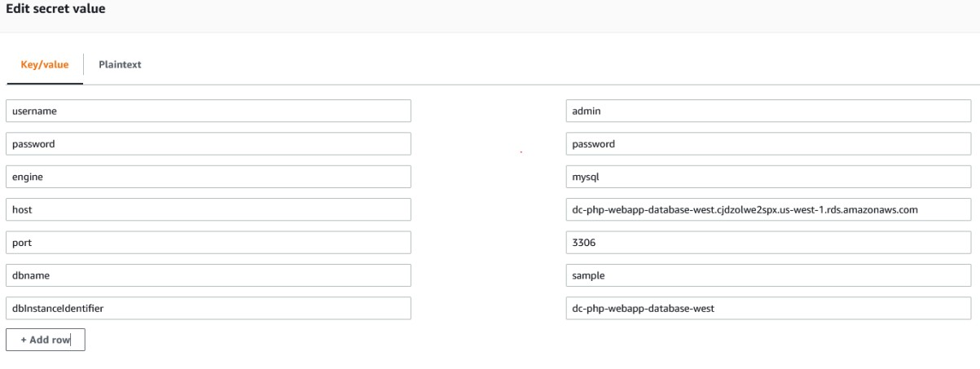

- Save the changes. The application in the us-west-1 Region should now be able to connect to the database.

Task 3 – Delete the Auto Scaling Group
We will now delete the auto scaling group in the primary Region (us-east-1) which will cause a health check failure and result in a failover.
- Go the primary region and locate the Auto Scaling group.
- Delete it – this will terminate the instances and leave no targets behind the load balancer.
- You should see this in action if you enter the URL of the us-east-1 Load Balancer in your browser.
- We should, however, still be able to interact with the website using the domain name – if we can this means that the failover has worked – as the only resource sitting behind the domain name is the resources hosted in us-west-1.

